**How to Install Jenkins on Windows**

<https://www.blazemeter.com/blog/how-to-install-jenkins-on-windows>

<https://www.youtube.com/watch?v=MlvNXFdPhB8>

How to provide rights to “Run Windows Service” to a user account as required for Jenkins Installation

When installing a service to run under a domain user account, the account must have the right to logon as a service. This logon permission applies strictly to the local computer and must be granted in the Local Security Policy. Perform the following to edit the Local Security Policy of the computer you want to define the ‘logon as a service’ permission:

1. Logon to the computer with administrative privileges.
2. Open the ‘Administrative Tools’ and open the ‘Local Security Policy’
3. Expand ‘Local Policy’ and click on ‘User Rights Assignment’
4. In the right pane, right-click ‘Log on as a service’ and select properties.
5. Click on the ‘Add User or Group…’ button to add the new user.
6. In the ‘Select Users or Groups’ dialogue, find the user you wish to enter and click ‘OK’
7. Click ‘OK’ in the ‘Log on as a service Properties’ to save changes.

Then try again with the added user.

<https://www.youtube.com/watch?v=FX322RVNGj4>

The above Tutorial is 2:56 hrs long but excellent for Jenkins and Maven both

**Jenkins Feature Details are available at following links:**

<https://www.tutorialspoint.com/jenkins/jenkins_quick_guide.htm>

<https://www.tutorialspoint.com/jenkins/index.htm>

<https://support.microsoft.com/en-us/windows/create-a-local-user-or-administrator-account-in-windows-10-20de74e0-ac7f-3502-a866-32915af2a34d>

**Screen Snapshots of Step by Step Approach of Jenkins Installation on Windows Platform**

# How to Install Jenkins on Windows

This post was updated in January 2021.

[Jenkins](https://jenkins.io/) is one of the most popular tools for continuous integration and continuous delivery on any platform. As a Java application, [Jenkins](http://www.blazemeter.com/jenkins?utm_source=blog&utm_medium=BM_blog&utm_campaign=how-to-install-jenkins-on-windows) has many plugins for automating almost everything at the infrastructure level. The use of Jenkins has widely increased rapidly due to a rich set of functionalities, which it provides in the form of plugins. In this blog we will show you a step by step guide of how to install Jenkins on a Windows platform.

Let’s get started.

First, you need to install OpenJDK. Jenkins currently only supports JDK8. If you need help with installing Java [please look at the steps here.](https://www.blazemeter.com/blog/how-to-install-gatling-on-windows?utm_source=blog&utm_medium=BM_blog&utm_campaign=how-to-install-jenkins-on-windows) Once Java is running, you can install Jenkins.

1. Click [here](https://www.blazemeter.com/blog/%E2%80%9Chttps:/www.jenkins.io/download/thank-you-downloading-windows-installer-stable%E2%80%9D) to download the latest Jenkins package for Windows (currently it is version 2.130).

2. Unzip the file to a folder and click on the Jenkins **exe** file.

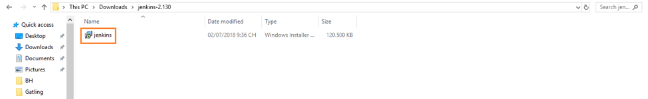

(All processes are the same in the new Jenkins UI).

3. Click **“Next”** to start the installation.

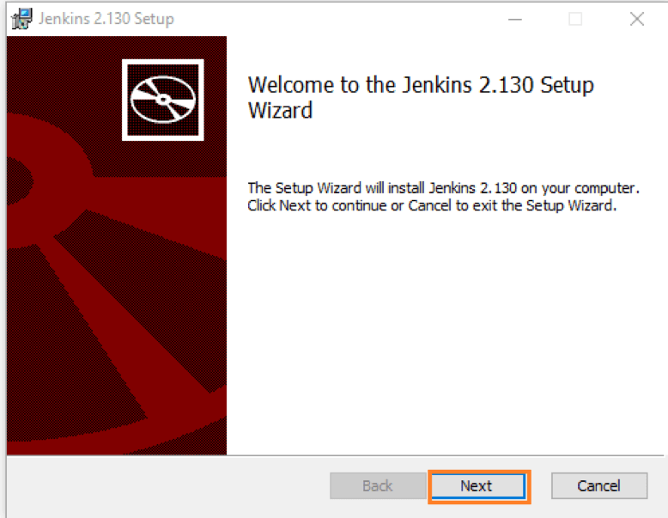

4. Click the **“Change…”** button if you want to install Jenkins in another folder. In this example, I will keep the default option and click on the **“Next”** button.

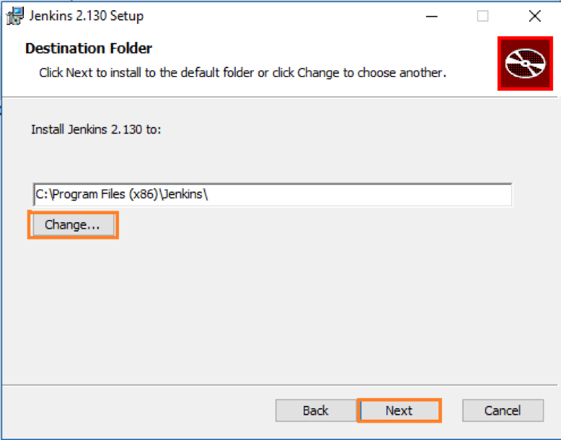

5. Click the**“Install”** button to start the installation process.

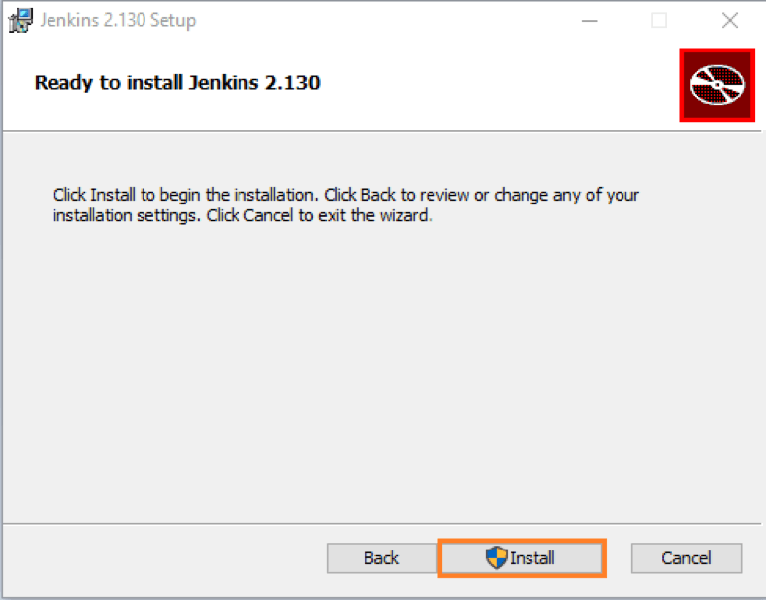

6. The installation will proceed.

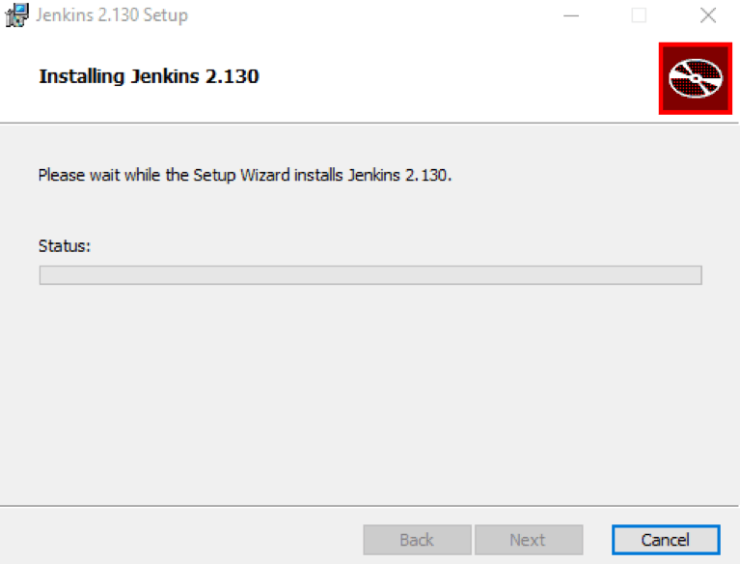

7. When done, click the **“Finish”**button to complete the installation process.

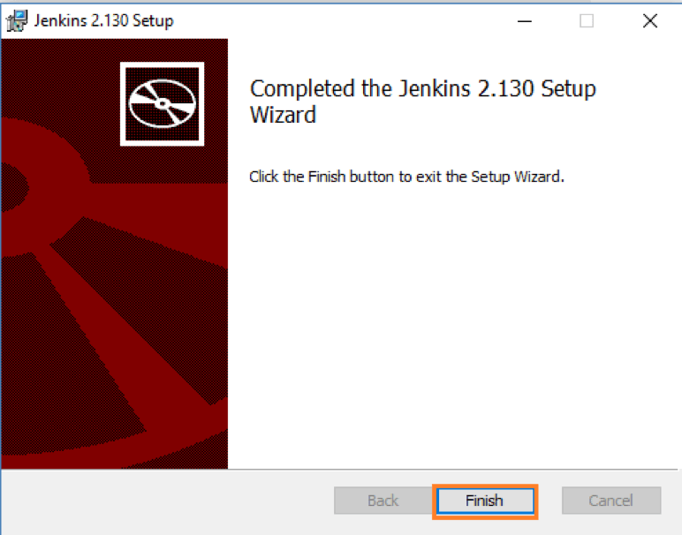

8. You will automatically be redirected to a local Jenkins page, or you can paste the URL [http://localhost:8080](http://localhost:8080/) in a browser.

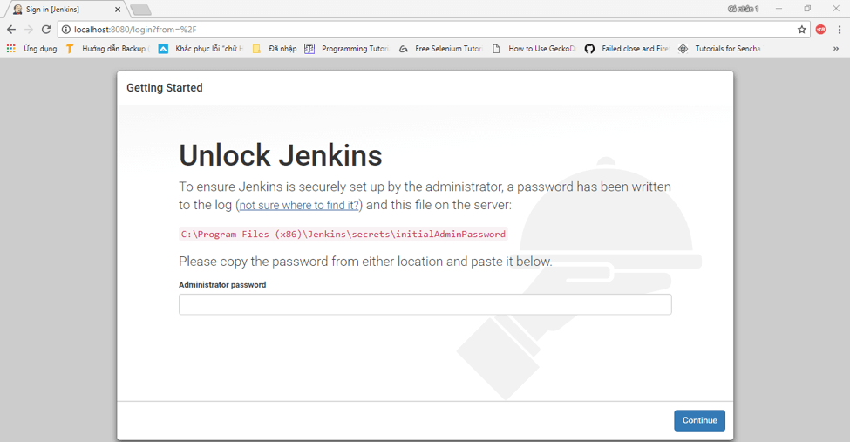

9. To unlock Jenkins, copy the password from the file at**C:\Program Files (x86)\Jenkins\secrets\initialAdminPassword** and paste it in the **Administrator** **password** field. Then, click the **“Continue”** button.

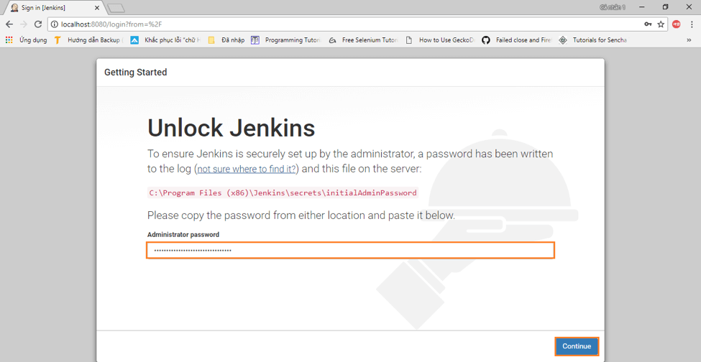

10. You can install either the suggested plugins or selected plugins you choose. To keep it simple, we will install the suggested plugins.

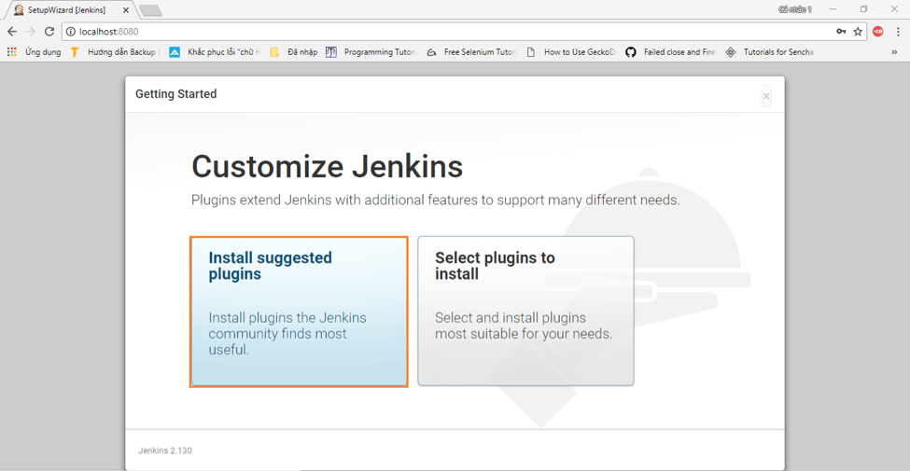

11. Wait until the plugins are completely installed.

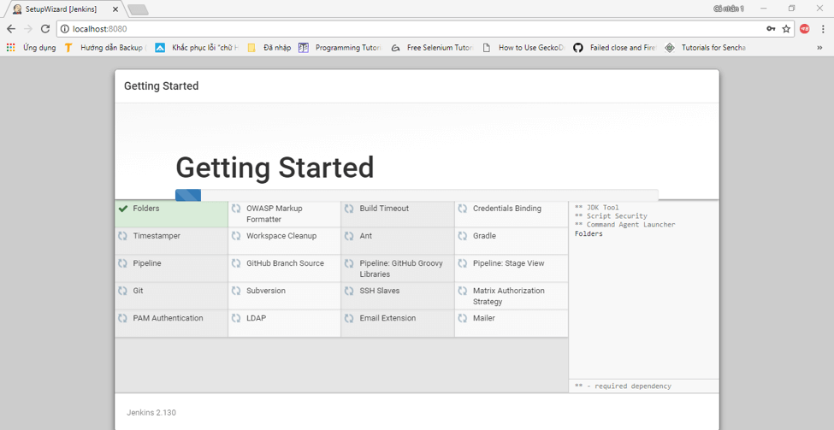

12. The next thing that you should do is create an Admin user for Jenkins. Then, enter your details and click **“Save and Continue”**.

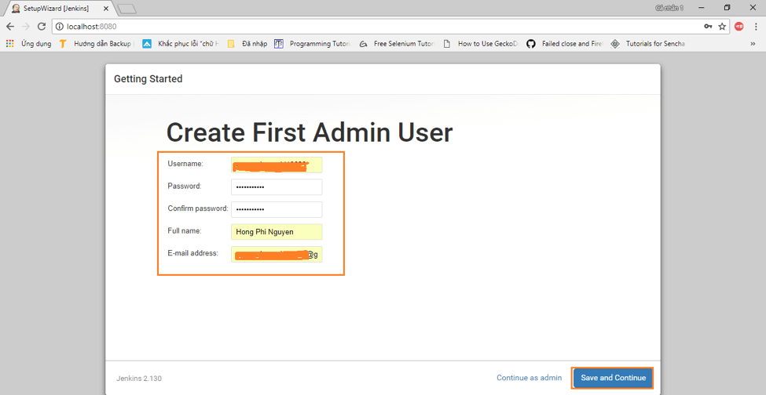

13. Click **“Save and Finish”** to complete the Jenkins installation.

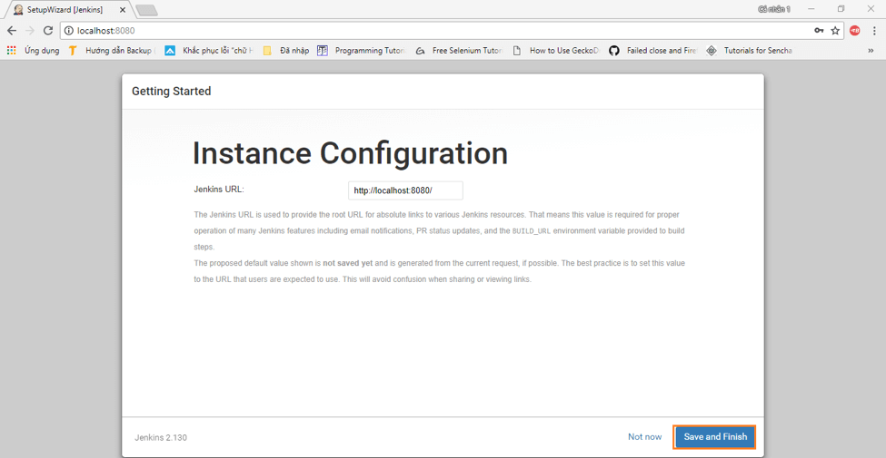

14. Now, click **“Start using Jenkins”** to start Jenkins.

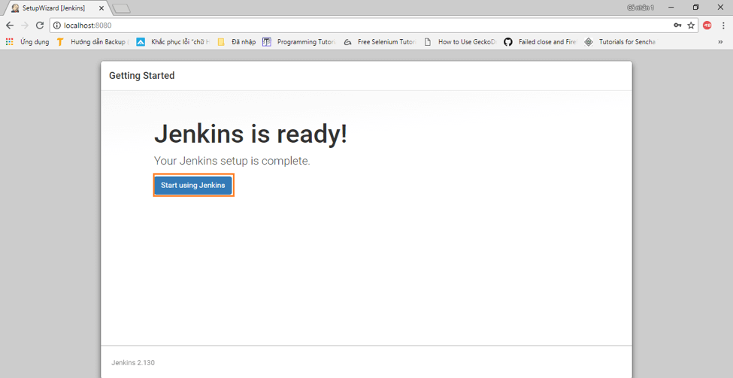

15. Finally, here is the default Jenkins page.

